**DineEase** – Restaurant Web Application

DineEase is a full-stack restaurant web application developed using React.js for the frontend and modern web tools for styling and optimization. It features responsive design, modular component architecture, JSON-based menu handling, and routing using React Router DOM.

The application includes multiple interactive pages such as Home, About, Menu, Team, and Reservation form, offering a complete mock restaurant experience.

Below are the key UI screens of the DineEase project.

**📸 1. Home Page**

**Description:**  
Landing section with restaurant branding, navigation bar, and a welcoming hero area.

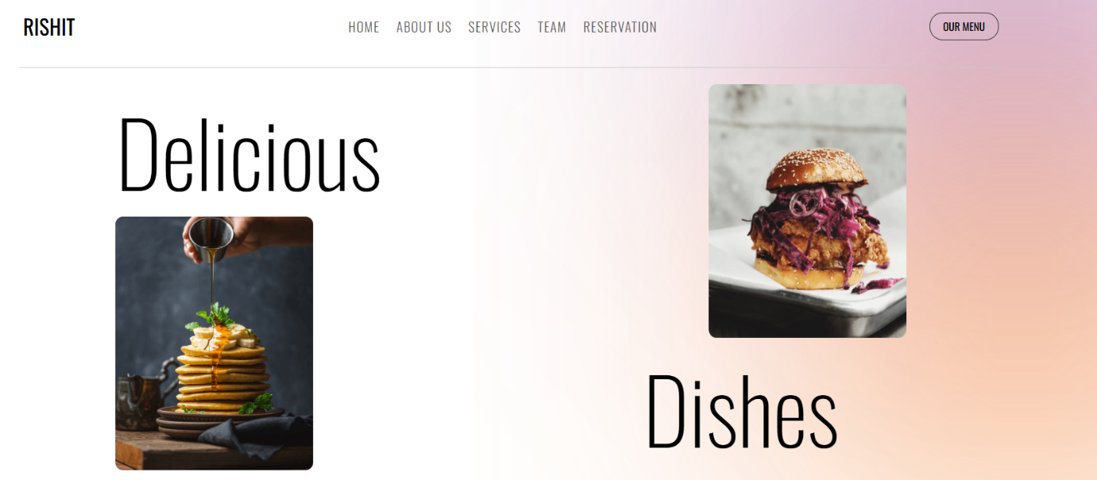

**📸 2. About Page**

**Description:**  
Introduces the restaurant’s story and values with a centered layout and subtle styling.

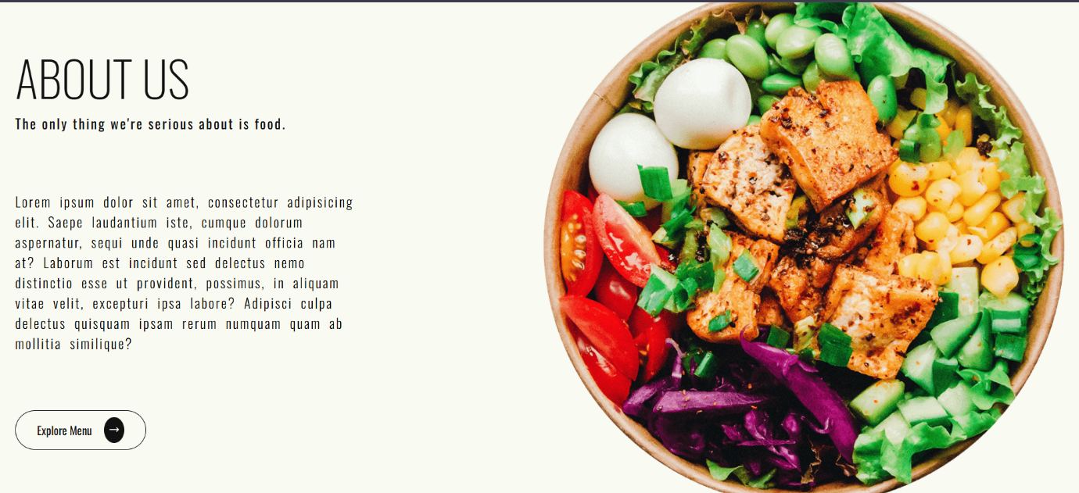

**📸 3. Menu / Food Page**

**Description:**  
Displays a collection of dishes with images and names, structured in a responsive grid.

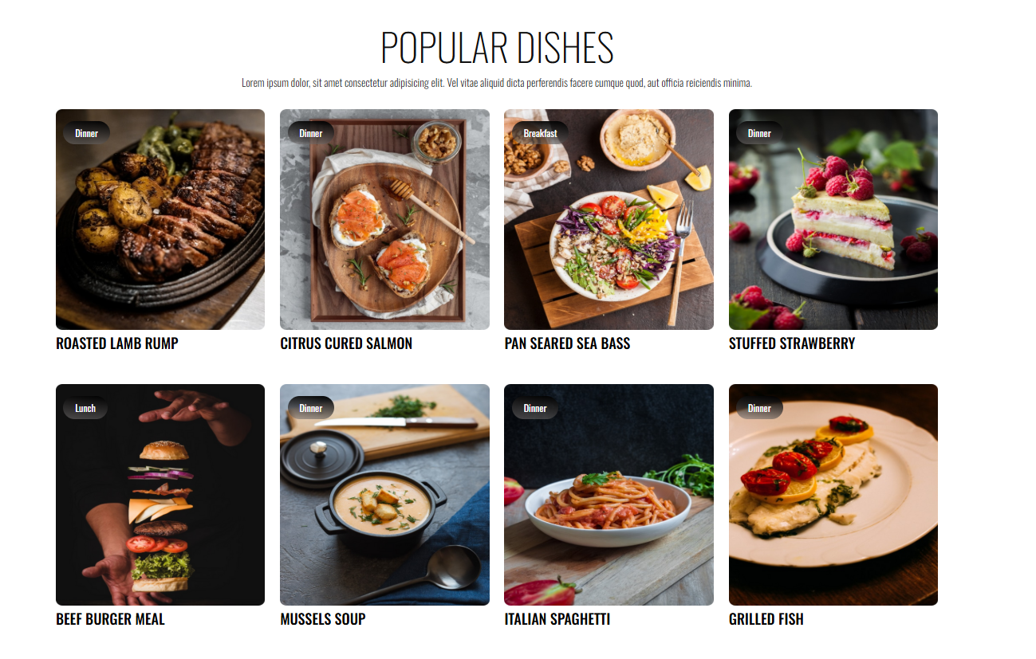

**📸 4. Features Section**

**Description:**  
Highlights key features or selling points of the restaurant, such as fast service, quality food, or ambiance.

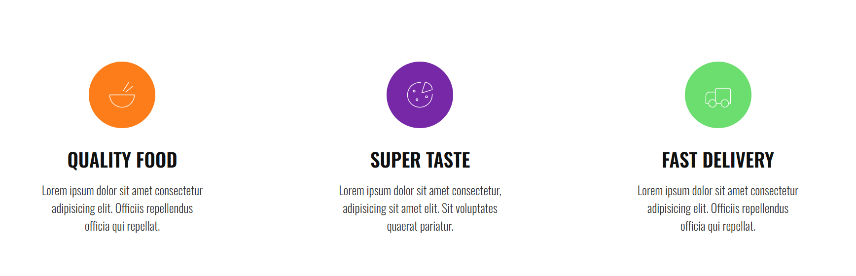

**📸 5. Statistics Section**

**Description:**  
Visualizes numbers like dishes served, customers, or years of service in a stylized layout.

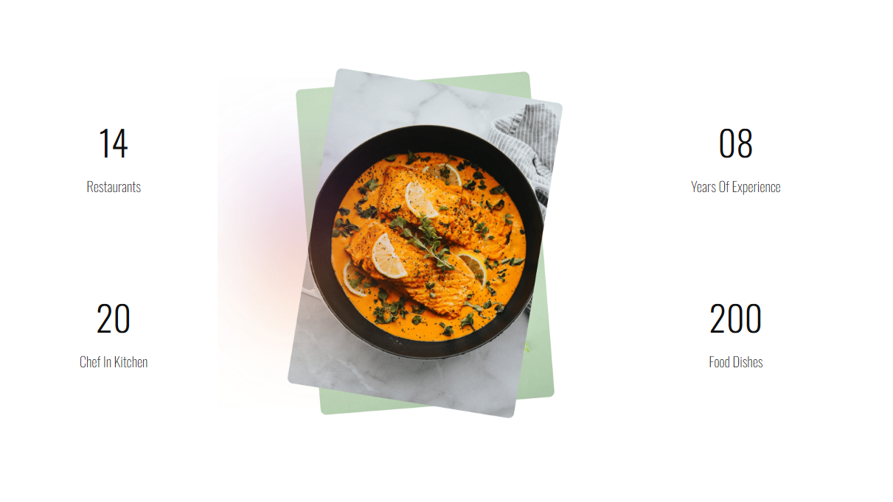

**📸 6. Team Page**

**Description:**  
Displays the team or staff members using cards with profile pictures and names.

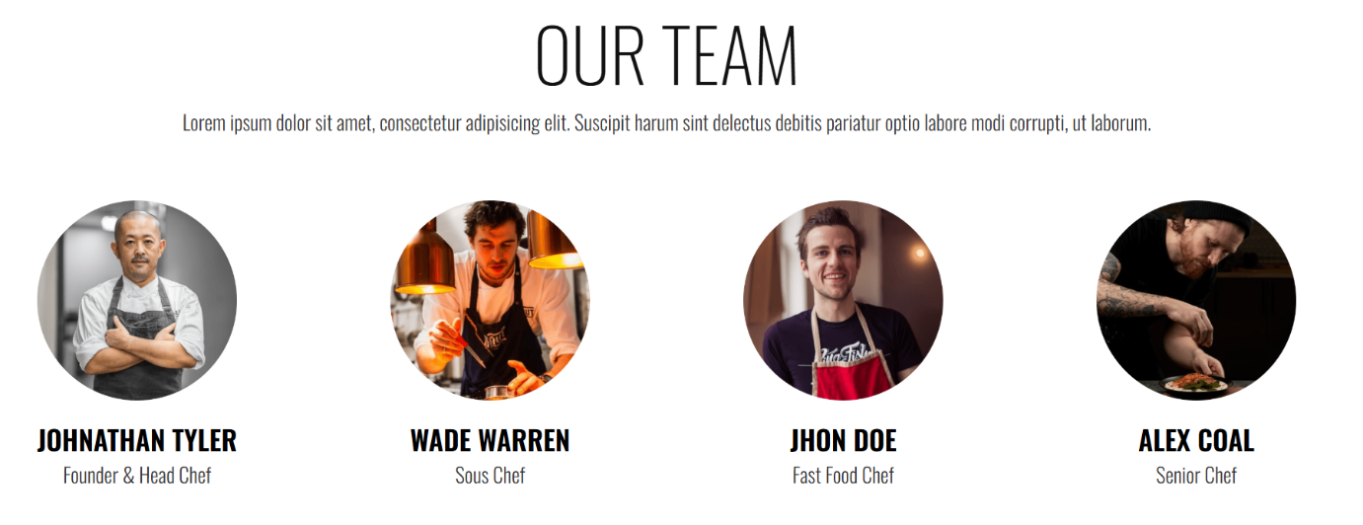

**📸 7. Reservation Form**

**Description:**  
A form that allows users to book a table by entering details like name, email, phone, date, and time.

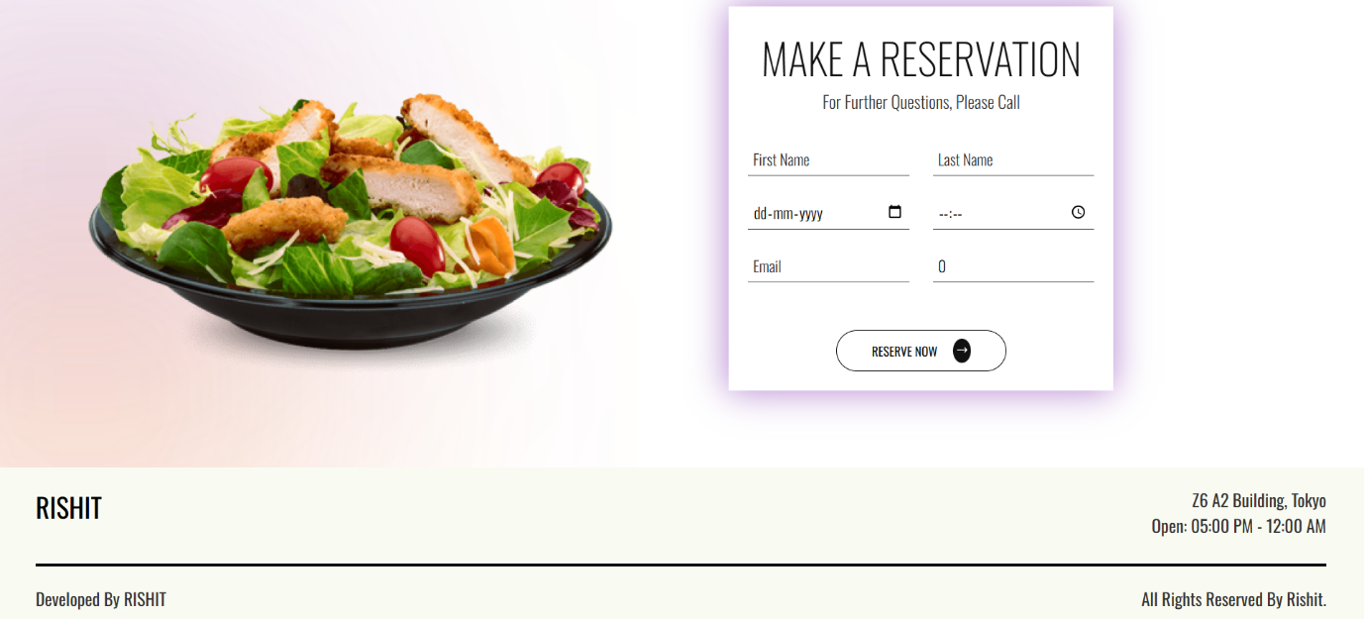

All screenshots are from the local development instance of DineEase. The project is available publicly at:

GitHub Repo: <https://github.com/dvrishit/DineEase>